Term Project: Analysis of Environmental Data
EVSC 4080/7080 and EVHY 4559/7559 Computational Methods
Spring 2026
Due dates shown with each component

Objective: To apply concepts from class to perform a complex environmental analysis to address a research question through data analysis.

Components:

Proposal (due Fri Feb 6 11:59PM on Canvas): A short proposal outlining your idea and research question

Project Consultations (Not graded but highly recommended; weeks of Feb 16/23): meet with instructor for informal update, ask questions, and to get help with scoping project.

Project Workflow (due Fri Feb 20 11:59PM on Canvas): A document outlining your overall methods, data, sources, etc. as well as outlining some basic figures/analysis

Preliminary Results (due Fri Apr 3 11:59PM on Canvas): A R notebook or interim report that highlights progress, roadblocks, and revisions to your project workflow

Final Presentation (Weeks of April 20 and 27 in class). A final presentation/poster based on your findings.

Project Reflection (due Tue Apr 28 11:59PM on Canvas): Answer some reflection questions on your project and submit a stand-alone figure (or multi-part figure), graphic, or animation that showcases your core results, and provides older iterations of visualization and documents your thought process of communicating your data.

Guidelines:

References: You may use a reference style of your choice. References will not count in your page limit.
Submission: Please submit a digital version of your assignment (preferably as .pdf) on Canvas. If you’re working in a group, please let the instructor know so that we can make a group on Canvas.
Notes:
- You are not locked into this document; your scope will evolve as you explore data and conduct analyses.
- You will receive feedback and suggestions throughout the semester. The more information you can provide at each stage, the more feedback the instructors can give back.
- If you have a unique or unconventional topic idea, feel free to discuss it!

Project Workflow

Now that you have some feedback for your project, deliverable 2 will be an extended version of your initial proposal with several structured sections:
- Data/references
- Workflow diagram/sketch/model structure
- Proposed figures
- (Revised) research questions
This will encourage you to start accessing data and thinking about what sorts of analyses you can do.
Proposal Requirements
Your project proposal will likely be 2-4 pages and submitted on Canvas as a pdf. There will be no penalty for being shorter/longer but you should have the following four sections:
- Data/References (3 pts)
- Start looking for and downloading data
- Write a brief paragraph on the data describing what data you have and, most importantly, if there are data you need but don’t know how to get.

- Provide a table for each data type with the following headings (if applicable)
- Data name
- Source/Reference (website, reference, article, etc.)
- Spatial/temporal coverage/duration
- Spatial/temporal resolution
- Temporal frequency
- Units
You don’t need to download every single dataset needed for your project now BUT the more you understand what you’re working with, the better you can understand if your scope is feasible.
- Project Workflow (3 pts)
You will need to think critically about how to take your data, subset/transform/model it into useful outputs for your analysis. Think of this as visual pseudocode. We want to envision the workflow about what the data starts as, what we need to process it, and what it will come out as.
- Briefly describe the workflow and most importantly, if there are steps you don’t know how to perform or if there are gaps where you don’t know how to go from one step to another. For models (e.g. linear regression, random forest, etc.) you should describe what your independent and dependent variables are.
- Create a workflow diagram to illustrate how you will go from raw data to final figures.
  - Use the following symbology for your diagram (see Appendix A below for an example).
Interim/ Processed Data
Raw Data
Figure 1

Analysis/Data Processing
Figure 1
- Potential Final Figures (3 pts)
Related to the Section 2 workflow, we want to conceptualize several potential figures that would help us visualize our research question. Provide the following:
- Either sketch (doesn’t have to be super-refined, can be hand-sketched and you upload a photo) or describe at least 3 figures that you want to create that would showcase the central analysis and ideas from your project.
- One of the figures should represent a more ‘complex’ analysis and visualization (e.g. not a simple time series of your data). Ask yourself, how can I summarize, split, and/or extract some meaningful (but concise) information about your data?
- Revised Research Questions and Likely Gaps in Knowledge (1 pt)
Describe your research questions/goals in more detail, given what you’ve developed in the previous sections. Briefly describe possible points along the analysis that you don’t know how to approach, start, etc.
If you’re working in a group, briefly describe how you would split the workload, and how you plan to share code, data, etc.

Rubric

 | Points
Data and References  Description of data needed/found, with table of data characteristics | 3
Project Workflow  Shows clear path of analysis (or with gaps identified) of how to take data towards final analyses and figures | 3
Potential Final Figures  Describes/Sketches of 3 different final figures to showcase analysis | 3
Revised Research Question and Knowledge Gaps:  Briefly describes current research direction (or re-state from proposal if unchanged). Also describes potential gaps in coding knowledge to complete analysis.  Groups: Includes brief discussion on workload distribution and how to work together | 1

Appendix A: Example of a graphical workflow

Can be done in PowerPoint, etc. Note that you do not need your entire project mapped out now, nor do you need to know the exact names of functions or analyses that you’re hoping to conduct. The main point of this exercise is to help you see a path to the final product, and where you may need help.

You might have multiple workflows (e.g. one for each figure), so don’t feel like you need to have this as one large ‘pipe’.

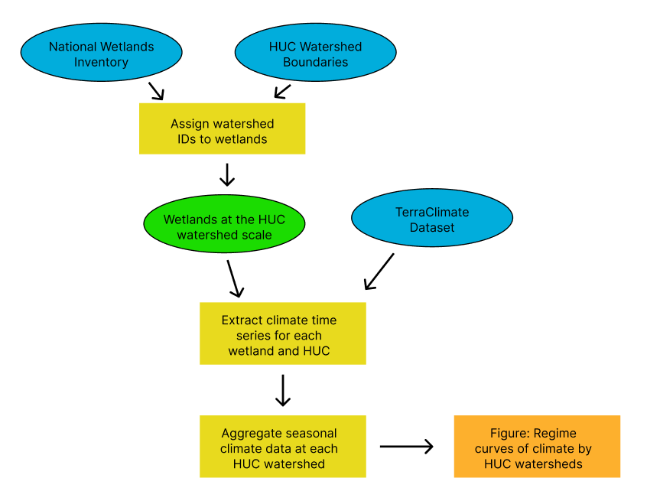

Appendix B – Example Sketches for Potential Figures
